**Modelling Approaches for masonry structures**1 Finite element modelling approach

-generally used where bricks and joints are modelled separately,has ability to model local effects and reproducing the behavior of masonry walls in which high local stress and stress gradients are present(eg walls subjected to concentrated loads from beam supports)

-while modelling with FEM ,the presence of vertical and horizal mortar joints causes the masonry to be anisotropic .so two different approaches are adopted to model such anisotropy i.e micromodel or two -material approach and macromodel or equivalent -material approach.

-in the two- material model ,the discretization follows the actual geometry of both the blocks and mortar joints.

-The equivalent-material approach assumes that the masonry structures is a homegenoeous continuum to be discretized with a finite element mesh which does not copy the wall organism,rather the single element will have a constitutive model which must be capable of reproducing an average behavior.

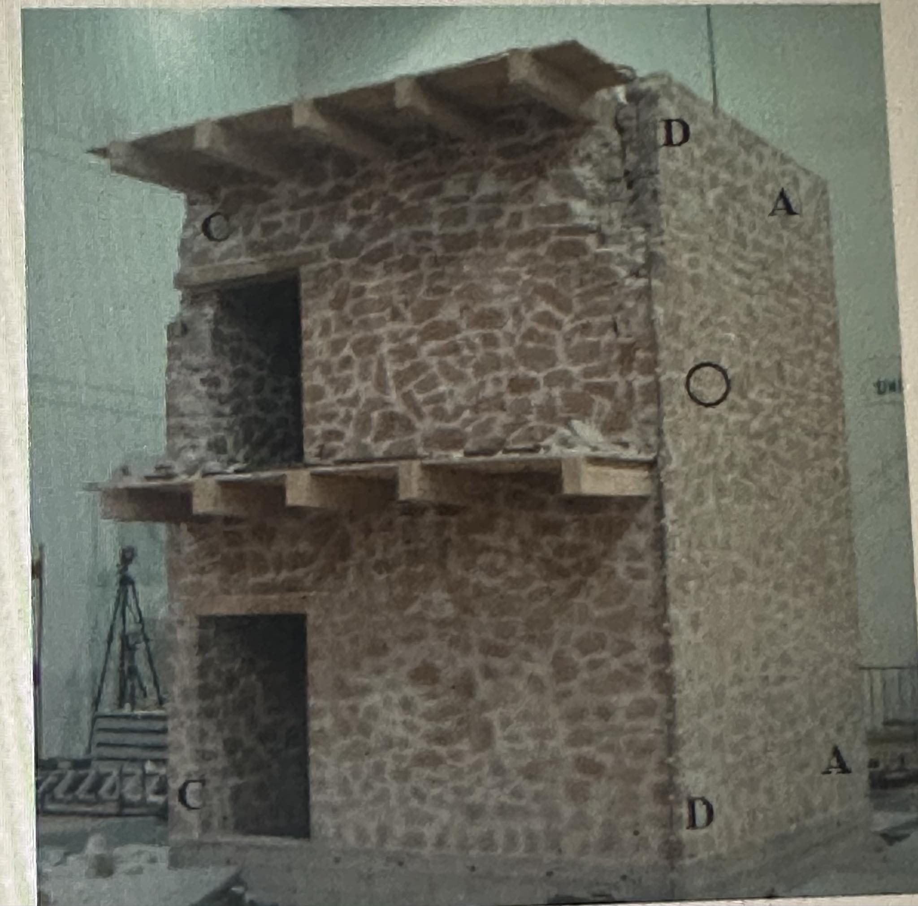

Brief description on modelling of the above prototype By FEM approach

-8 nodes isoparametric solid elements(solid65)were used to model both the masonry walls and RC basements.

-the wooden joist were modelled by using one dimensional two-node isoparametric elements while 2-d isoparametric elements wth 4 nodes used for modelling wood planking.

-0-dimensional one node element were inserted on each floor to consider the additional masses.

-The constitutive behavior of the masonry was reproduced assuming an electroplastic law with tension cutoff.to aim this,Drucker-Prager plasticity model was combined with the William-Warnke failure criterion,which allows for an elastic brittle behavior in case of biaxial tensile stress.

2.Macro element model approach

-Used for the analysis of large size models.

-performs a 3D step-by-step dynamic analysis of regular masonry buildings subjected to a base ground acceleration.

-Each masonry wall is represented by piers (with vertical axis and height equal to the inter -storey)and sprandels(with horizontal axis).

-only the piers are considered as deformable and resisting element whereas the spandrels have infinite stiffness and strength.

-rotational elastic springs between piers and floors is generally introduced in the model to reduce the shear stiffness of the panels.

-ra yauta paper ma , pier ko 4/11 fraction of mass is attributed to the first floor ra 7/11 rests on foundation .similarly the 7/11 fraction of second lvl pier mass is attributed to first floor and remaining 4/11 to second floor and so on.,lekhethyo.

3.Modelling with Discrete Element Method

-the structure is considered as an assembly of distinct blocks,rigid or deformable ,interacting through unilateral elasto-plastic contact elements which follows the coulomb slip criterion for simulating contact forces.

-This method is based on a formulation in large displacement(for the joints)and small deformation (for the blocks)and can correctly simulate collapse mechanisms due to sliding,rotation n impact.

4.Modelling with interface elements: the FEMDE(Finite element method with discontinuous elements)

-In this approach,the blocks are modelled using conventional continuum elements,linear and non-linear,while mortar joints are simulated by interface elements,the “joint elements ”,made up of two rows of superimposed nodes as in figure with frictioin constitutive law.A diagram of a diagram

Ra Haridarsan Shrestha sir ko(Capacity Assessment of stone masonry building of jumla district)

-Esma pani FEM modelling (fem ko pani micro modelling approach)use vaxa.

-Three dimensional 8 nodded hexahedral element with reduced integration (3CD8R-continuum 3-D,8-node,reduced integration)has been used to model the both masonry and timber elements.